
Christmas

To Do List

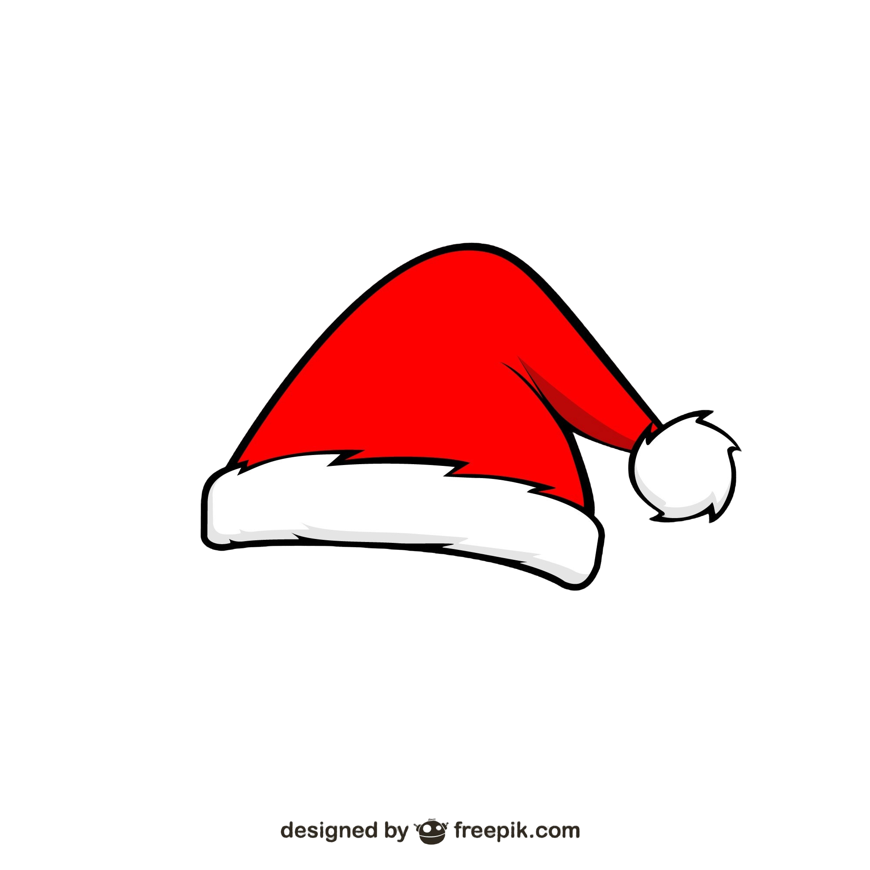
☐
Build a snowman
☐
Watch a holiday movie
☐
Write to Santa
☐
Bake cookies
☐
Wrap gifts
☐
Decorate Christmas Tree

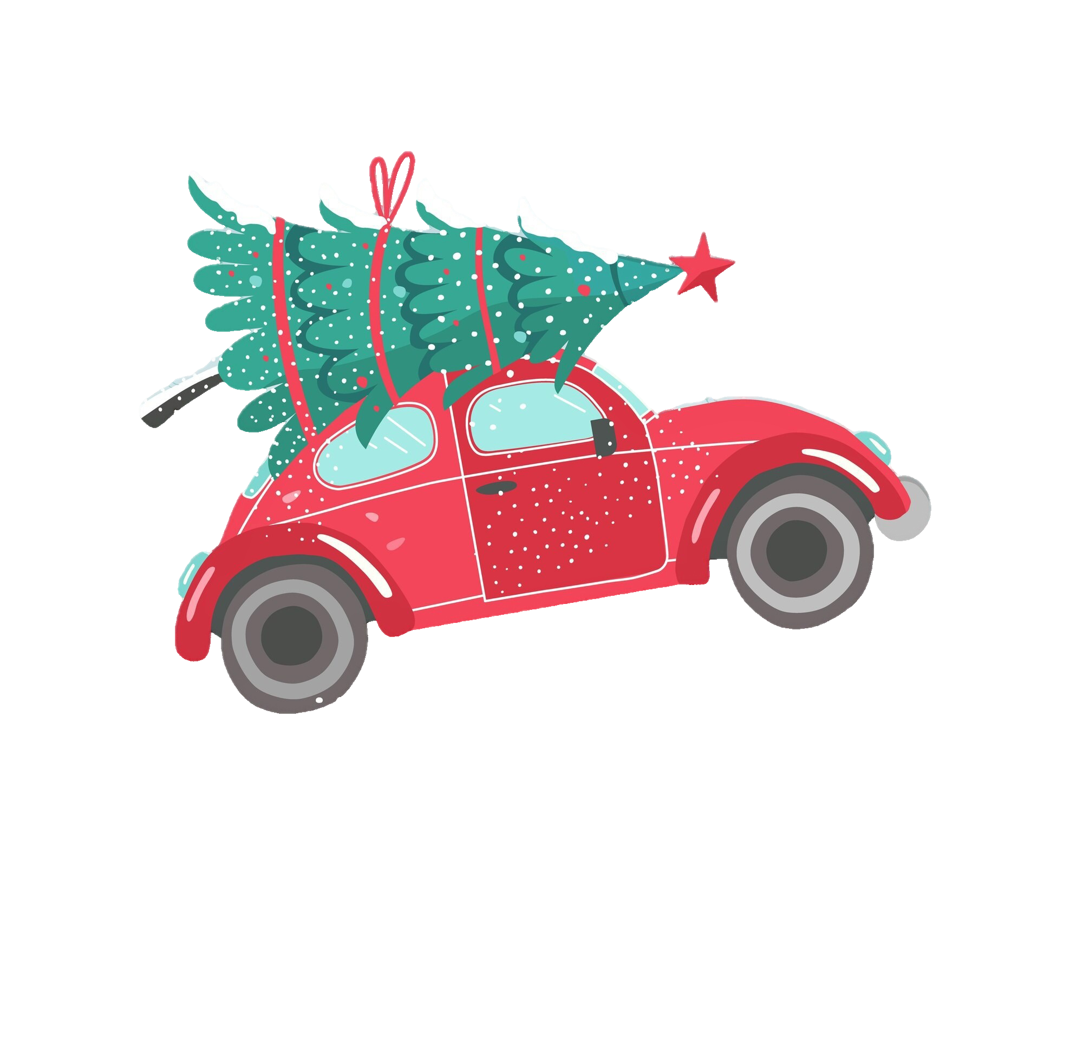

Instructions for Use
To use this template, please adhere to the conditions outlined below.
You are allowed to:
- Modify this template to suit your needs.
- Employ this template for both personal and commercial projects.
You are not allowed to:
- Sublicensing, selling, or renting this template or any modified versions thereof.
- Distributing the Template or any modified versions or including it in a collection such as a database or any other product or service that offers downloadable assets (e.g., images, icons, templates) for redistribution or resale.
- Utilizing any individual elements of this template in isolation from the template itself.
- Registering any part of this template as a trademark or logo or claiming any part as your own intellectual property in any registry or similar entity.
For detailed information, please review our Terms and Conditions.

Fonts Used:
- Cinzel: https://fonts.google.com/specimen/Cinzel
- Comfortaa: https://fonts.google.com/specimen/Comfortaa
- Style Script: https://fonts.google.com/specimen/Style+Script

