
Christmas

To Do List

☐
Decorate the House

☐
Buy a Christmas Tree
☐
Decorate Christmas Tree

☐
Wrap gifts
☐
Bake cookies
☐
Write to Santa
☐
Make a wishlist
☐
Build a snowman

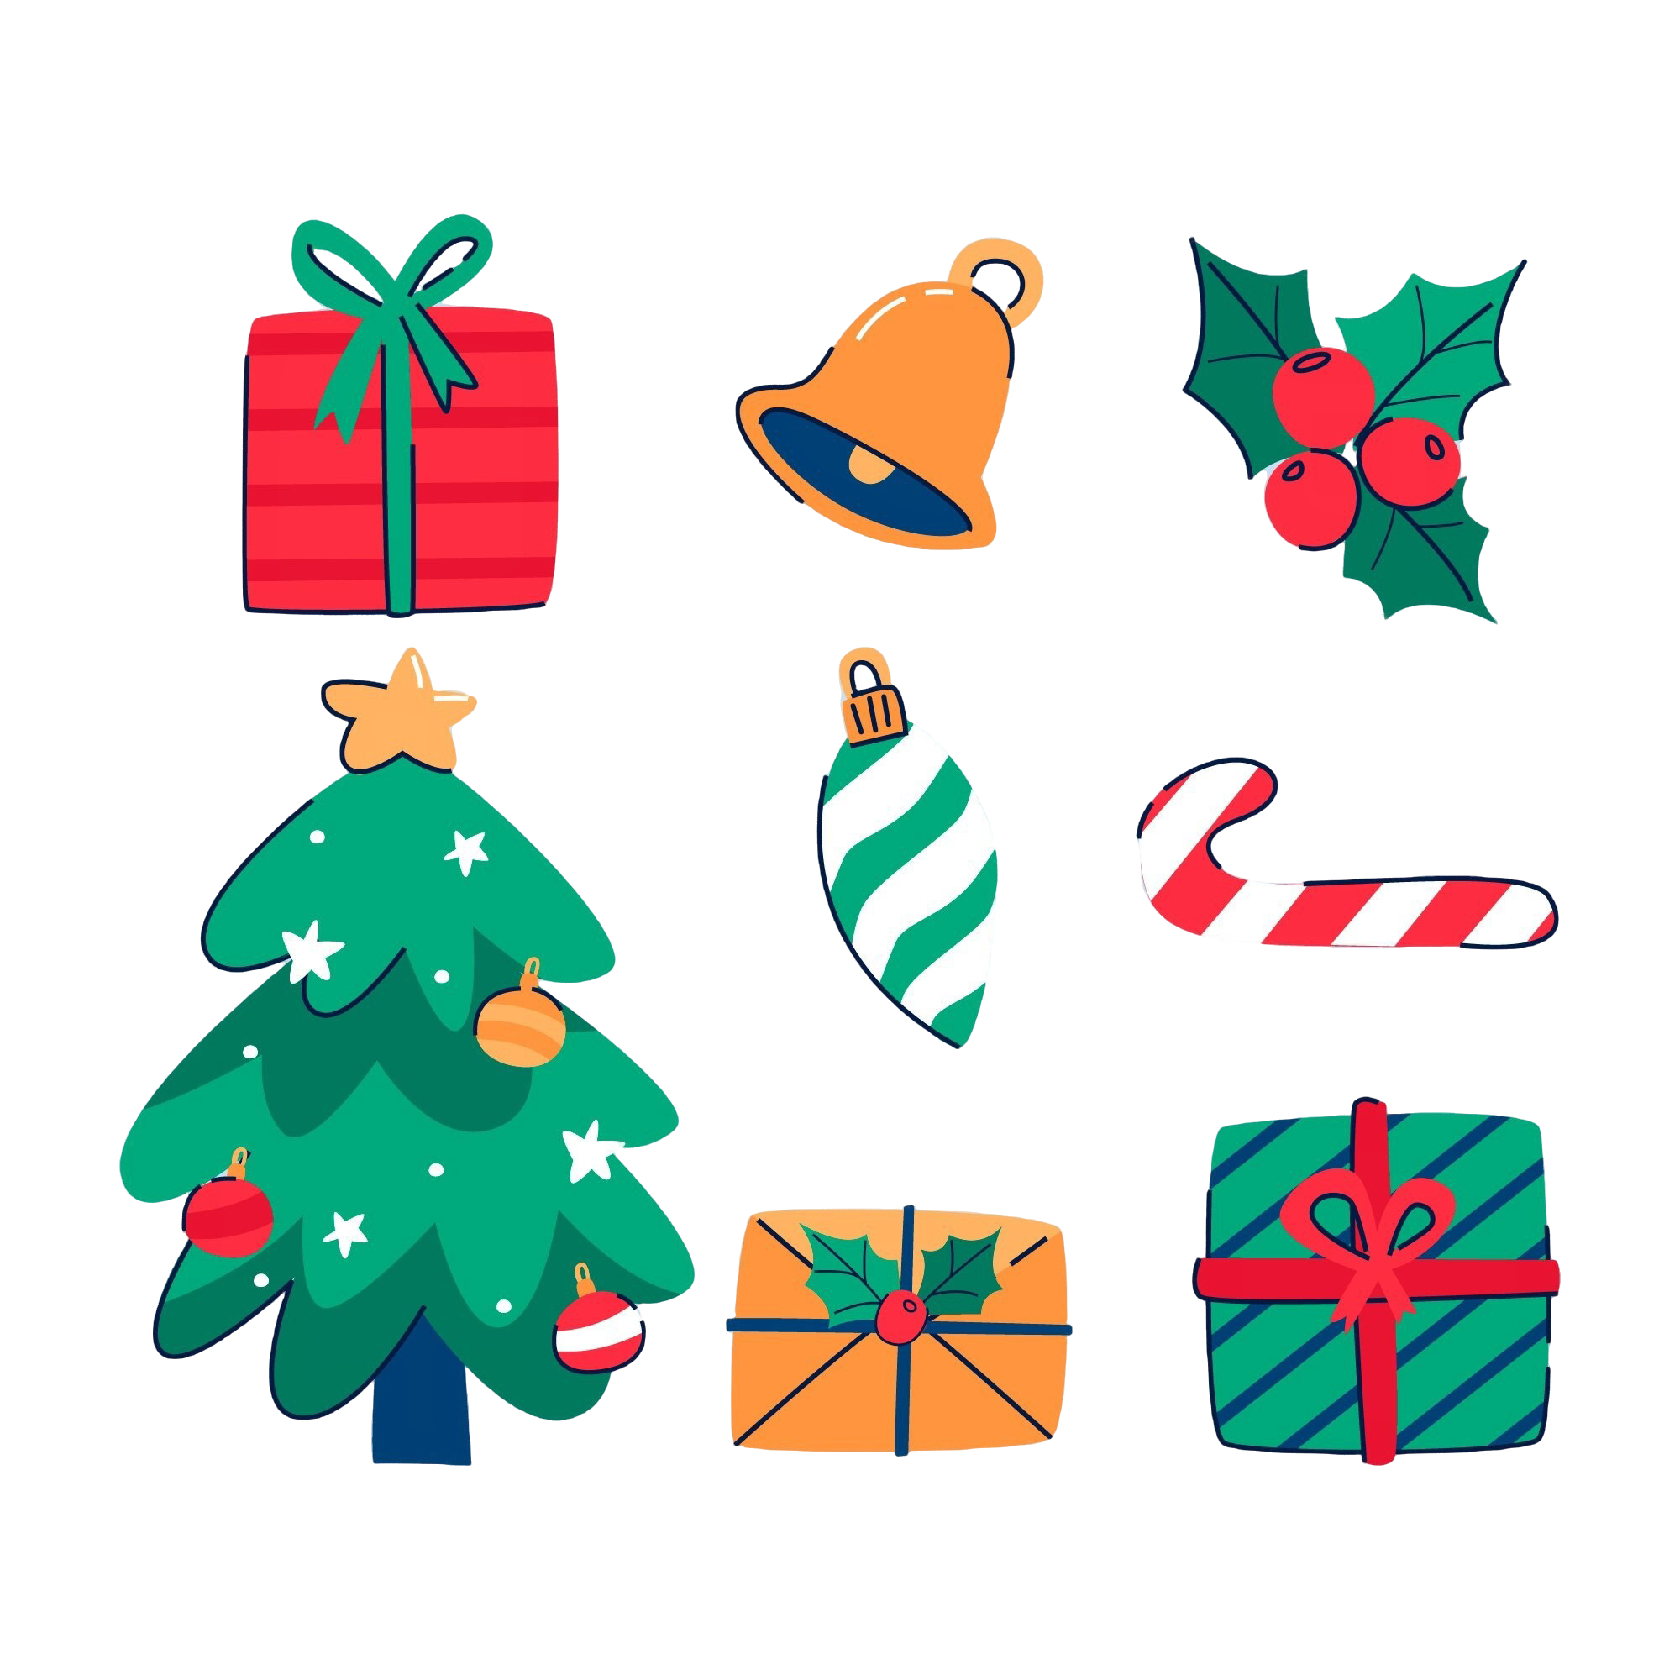

Instructions for Use
To use this template, please adhere to the conditions outlined below.
You are allowed to:
- Modify this template to suit your needs.
- Employ this template for both personal and commercial projects.
You are not allowed to:
- Sublicensing, selling, or renting this template or any modified versions thereof.
- Distributing the Template or any modified versions or including it in a collection such as a database or any other product or service that offers downloadable assets (e.g., images, icons, templates) for redistribution or resale.
- Utilizing any individual elements of this template in isolation from the template itself.
- Registering any part of this template as a trademark or logo or claiming any part as your own intellectual property in any registry or similar entity.
For detailed information, please review our Terms and Conditions.

Fonts Used:
- Berkshire Swash: https://fonts.google.com/specimen/Berkshire+Swash
- Julius Sans One: https://fonts.google.com/specimen/Julius+Sans+One
- Bad Script: https://fonts.google.com/specimen/Bad+Script

